Submitted date： (YYYY)/ (MM)/ (DD)
to the Safety Office Director, JASRI

Application to enter “TOKUREI-KUIKI” in NewSUBARU

Div./Dept.
Section Head* |  |  | Signature or name+seal
The person  in charge |  | Tel
It should be filled in the LASTI/ JASRI/RIKEN div./dept. of worker.
*Section Head : administrative post, group leader, and so on

The following person will apply for the approval to enter " TOKUREI-KUIKI " in NewSUBARU.
When this person enters " TOKUREI-KUIKI ", he/she must work in accordance with Radiation Safety Education on the back page of this application.
The worker need to fill in the form within heavy black-edged part and must read to understand the contents on the back of this form, and sign in the column on the bottom.
Affiliation | □JASRI |  |  |  |  |  |  |  |  |  |  |  | □LASTI
 | □Others（ |  |  |  |  |  |  |  |  |  |  |  |  |  |  |  |  |  |  |  |  |  | ）
Affiliated organization representative  (Excluding LASTI/ JASRI / RIKEN staff) | The person who admit the worker to work in NewSUBARU
 | Post
 | Name |  |  |  |  |  |  |  |  |  |  |  |  |  |  |  | Signature or name & seal
Worker’s name |  |  |  |  |  |  |  |  |  | IDNo.  fill in if you have an SPring-8 ID
Planned date of entry | (YYYY/MM/DD) |  |  |  |  | 20 | / |  |  |  | / |  |  |  | ~ | 20 |  |  |  | / |  | /
Area | □Experimental Hall |  |  |  |  |  |  |  |  |  |  | □Power Supply Area
 | □Others（ |  |  |  |  |  |  |  |  |  |  |  |  |  |  |  |  |  | )
Contents of work | □Construction work |  |  |  |  |  |  | □Inspection / Adjustment
 | □Others（ |  |  |  |  |  |  |  |  |  |  |  |  |  |  |  |  |  |  |  |  |  | ）
Note

【Method of confirmation of dose etc. and control target value】
Radiation dose | Measurement by survey meter | ：＜0.5μSv/h
Surface concentration  of radioactivity | Smear method or direct survey | ：＜1/100 of the surface concentration limit of radioactivity
Concentration in air | Measure the filter paper collected by the dust collector with a radiation ditector | ：＜1/100 of concentration limit in air
【Name of radiation safety supervisor who confirmed record】 Hidenori Toyokawa
安全管理室記入欄

承認日 | 20 年 月 日 |  | ICタグNo.
承認者 |  |  | 貸出日：20 年 月 日
 |  | 自署又は印 | 返却日：20 年 月 日
【Radiation Safety Education to enter TOKUREI-KUIKI】
(2024/02/01)
- For your safety, follow the warning (notice) board and SPring-8 staff’s instructions.
IC tag

- Contact to guard post (ex.119) immediately when the emergency (injury, fire, and so on) arise.
- Do not smoke, eat, drink, and make up in TOKUREI-KUIKI.
IC leader

- Do not get close to areas and equipments or apparatus irrelevant to your work.
- Do not transfer to others, acquisition, rent your “IC tag” of TOKUREI-KUIKI which JASRI lent it to you.
(IC tag: the plastic tag with IC chip)
- Use your “IC tag” for TOKUREI-KUIKI whenever you enter or leave the TOKUREI-KUIKI.
- Contact to JASRI Safety Office promptly if you lose or break “IC tag” for TOKUREI-KUIKI.
- Return “IC tag” for TOKUREI-KUIKI to JASRI Safety Office after your work is finished.
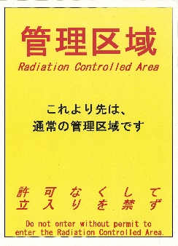
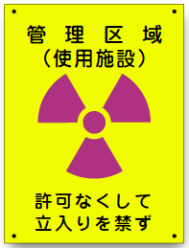
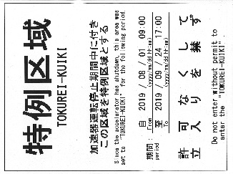
- There are two signs, Picture ⑴ shows TOKUREI-KUIKI, Picture ⑵ at doorway of TOKUREI-KUIKI. There is a denotation, Picture ⑶which shows “Radiation Controlled Area” at the door of Machine Laboratory. TOKUREI-KUIKI admittance worker do not enter there.
Picture (3)
Picture (1)
Picture (2)
- TOKUREI-KUIKI and periods set up are as follows.
Setting period：2024/03/05 9:00 a.m. – 2024/03/29 5:00 p.m.
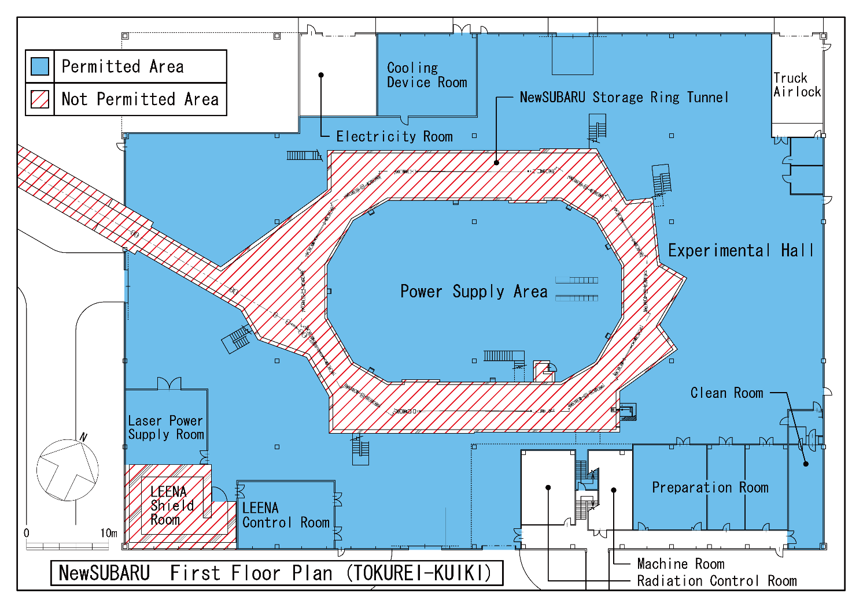

Storage Facility

Storage
Facility

I understand well about every articles of [Radiation Safety Education to enter TOKUREI-KUIKI].
ICタグ No. |  | Signature
(2024/02/01)

